June 2017
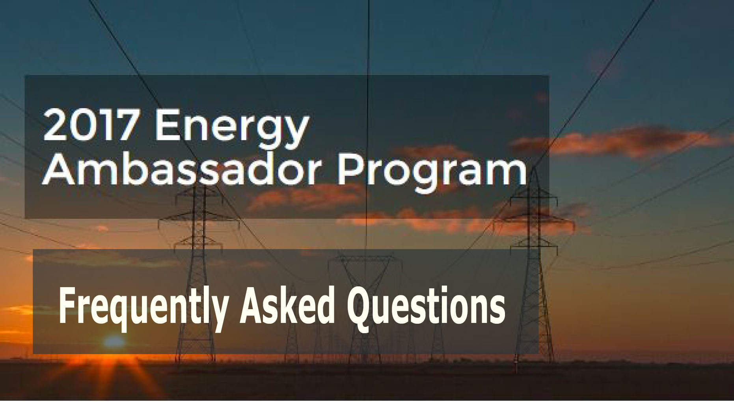

Contents
Visiting Businesses 101 3
• What constitutes a successful visit? 3
• Where can I find the Visit Tracking form? 3
• How should I prepare? 3
• Who should I speak with when visiting a business? 3
• How should I track the businesses I reach out to? 3
• What is the payment structure? 3
• Is there a minimum number of visits I should complete? 4
• Can I make visits in more than one city or area? 4
• What if a business I visit has more than one location? 4
• What should I do if there are two party IDs for one small business? 4
• What happens if I cannot answer a business owner’s question? 4
• What if a business has a different location or physical address they want me to visit? 4
• What if I encounter a language barrier? 4
Detailed resources for visits 4
• What is the PG&E’s Business Customer Service number? 4
• What are time-of-use hours and periods? 5
• Where can I find website information about time-of-use rates? 5
• Is there any information we can give businesses about LED light bulbs and energy efficiency? 5
• Where can I find rebate information? 5
• There is the “3rd Party Fee” appearing in the customer’s PG&E bill. What is this about? 6
• What should I do if a business requests an energy assessment? 6
• Why is the rate-analysis tool not available for this business? 6
Paychecks 6
• How often are paychecks issued? 6
• How should I count the number of visits to include in my invoice? 6
Webinars & Recordings 7
• Where do I find the recording of a webinar or training? 7

Visiting Businesses 101

What constitutes a successful visit?
A successful visit includes the following:
- Recording main energy-related concern
- Providing available resources relevant to energy-related concern
- Recording current level of satisfaction with PG&E
- Delivering Time of Use and YourAccount information

When possible, please collect a customer email and encourage customers to take a qualifying action. Qualifying actions include: registering for an online account, completing the Business Energy Checkup Tool, claiming a rebate, signing up for energy alerts, contacting the BCSC for assistance, and signing up for paperless billing.

Where can I find the Visit Tracking form?
Save this Visit Tracking form in your device or bookmarks for future access.

How should I prepare?
To begin with, we recommend becoming familiar with the PG&E website as well as the available tools and resources. You should know how to find more details about an account’s billing, how to set up paperless billing, sign up for energy alerts, and where to find the Business Energy CheckUp tool. Also, browse through the different types of rebates that are offered and know how to submit a rebate.
Additionally, make sure you review the resources available through the Energy Ambassador Resource Portal

We then recommend mapping your route beforehand using Google Maps or an app like Batch Geo. Bring your route, the addresses, names, and Customer IDs of the businesses you plan to visit, as well as pamphlets to hand out and your tablet for showing screenshots to customers. Dress nicely, preferably in your official ambassador shirt.

We recommend bringing a notebook or other method of recording customer responses as you go. It is most efficient to fill out the form AFTER the visit is completed (rather than during the conversation), so be sure you can remember or note what customers have told you. Don’t forget to bring water, sunscreen, and comfortable shoes.

Who should I speak with when visiting a business?
Since we are dealing with utilities and bills, you will ideally speak to someone in charge of accounts, administration, facilities, or operations. Some businesses are too small to have this sort of staff. In this case, look for a manager or owner. In general, you want to speak with someone who can talk to you about the business’ needs and energy-related concerns.

How should I track the businesses I reach out to?
Keep track of the status for each business on your list by recording it directly onto the shared parcel document. Use “Not yet visited” to denote a business that is in your pipeline and “Successful visit” to signal a business for which you have submitted a form. “No visit” indicates a business that you were not able to visit. Use the dropdown menu in the “Reason” column to specify why a visit was not possible, and elaborate if necessary in the “Comments” column.

Doing this allows us to see address and information changes in real time without you submitting a separate report. Note that for businesses you successfully visit, you must also submit the visit tracking form to be eligible for payment.

What is the payment structure?
Each successful visit earns $30, and each successful visit with a qualifying action earns $33. Each completed parcel list that is fully updated with the status of each business earns $40. Periodic bonuses will also be available for things like breaking an individual record or meeting a weekly minimum.

Is there a minimum number of visits I should complete?
After the first two introductory weeks, we expect ambassadors to complete 20-25 visits/week. If you anticipate a drop in your visits in a given week, please update the program manager as soon as possible.

Can I make visits in more than one city or area?
Yes, you can. Ambassadors work off of parcels, or lists of about 200 businesses within contiguous zip codes. Once you have reached out to at least 80% of your assigned customer list, you can request another in the same or a different area. We will do our best to accommodate location requests, pending availability.

What if a business I visit has more than one location?
Educating one business (with one business owner) counts as a single interaction, regardless of the number of locations, franchises, or account IDs.

What should I do if there are two party IDs for one small business?
The second ID means there are two meters, but this is still counted as one location. You can then use the comments field to make a note flagging the second ID for the same business.

What happens if I cannot answer a business owner’s question?
If there is a specific question or technical issue you cannot answer, you can refer the business to contact the Business Customer Service Center for further assistance. They can be reached at 1800.468.4743, Monday to Saturday from 7AM to 9PM.

What if a business has a different location or physical address they want me to visit?
PG&E has provided a target list of businesses they want for us to focus on. As such, businesses that are not on the list will be considered outside of the program area and thus non-eligible. Stick to the list and contact the program manager with any questions.

What if I encounter a language barrier?
Depending on the severity of this, you can either change the language of the PG&E’s web page, or contact BCSC for assistance. If translating the web page would help, you can select that feature by going to the top right-hand corner of the website and selecting between English, Spanish, or Mandarin.
If you need to contact the BCSC, keep in mind that there will likely be a wait time before you can get a translator on the line.

Detailed resources for visits

What is the PG&E’s Business Customer Service number?
The business customer service line is available at 1800.468.4743, Monday to Saturday from 7AM to 9PM. Direct customers here with any questions not answered in your materials.

- What is a Time-of Use (TOU) rate plan?
It is a plan in which the cost of electricity will vary based on the time of the day and season in which it is used. Previously, businesses were billed according to flat electric rates, which meant they were charged the same amount for electricity no matter when it was used. As part of a plan by the California Public Utilities Commission to ensure greater power reliability and a better energy future, TOU rate plans are now the commercial standard and soon residential as well, for all of the state’s major electric utilities.

What are time-of-use hours and periods?
Time-of-use rates are slightly higher during summer weekday afternoons when electric demand is higher, typically noon to 6 p.m., May through October. Time-of-use rates tend to be lower at all other times.

Why does my Time-of-Use rate vary?
Time-of-Use rate plans better align the price of energy with the cost of energy at the time it is produced. Lower rates during partial-peak and off-peak hours offer an incentive for customers to shift energy use away from more expensive peak hours, which can help save money and reduce the strain on the electric grid.

How can a business save money on a TOU rate plan?
Before, on a flat electric rate, the only way to reduce your bills was to simply use less electricity. On a TOU rate, businesses can lower their bill by shifting when they use energy to partial-peak and off-peak hours. Rates during partial-peak and off-peak hours of the day are lower than the rates during the peak hours of 12- 6 p.m. on weekdays. This puts customers in the driver’s seat so they can have more control over their bills. Some resources available through the online account provide businesses with tools to measure and monitor their electricity use. PG&E also helps customers conserve energy by providing them with rebates for making energy efficient upgrades.

Where can I find website information about time-of-use rates?
On the PG&E online page: https://www.pge.com/en_US/business/rate-plans/rate-plans/time-of-use/time-of-use.page
On the right-hand side of the page, you’ll find an email and phone number where business customers can call for more info. This a good place to point the customer to for more detailed information.

What is a peak period?
Current peak periods occur from noon to 6 p.m. May through October, when Time-of-Use rates are higher

Is there any information we can give businesses about LED light bulbs and energy efficiency?
Review the “Turning Myth to Motivation” training video for a refresher on different types of lighting for businesses. In a pinch, remember that replacing incandescent lightbulbs with LEDs or compact fluorescents can save $10-$20 annually per bulb. For more detailed questions, you can use this online calculator to estimate the savings possible for a specific business (we recommend saving the link to share with businesses). Remember that a PG&E representative at the BCSC can always help with the specifics or details about a particular account.

Where can I find rebate information?
First, take a look at the micro product reference guide to see whether information is available online or only through a trade pro (local contractor) install. If available online, you can visit PG&E’s business rebate page here or in the Rebate FAQ page. If only available through a trade pro, the customer will need to contact them directly. Remember: trade pros are not a free service, but they will handle details, installation, and paperwork.

If the business owner is interested in filling for a rebate by themselves, you can find a rebate application package here. It contains instructions, overview information on energy saving tips, and a rebate application. The customer can then contact the Business Customer Service line for further info.

*Note: You will need the make and model of the product in order to request a rebate.

How long does a business have to claim a rebate?
Complete applications must be postmarked and received by PG&E’s Application Management Center within one year from installation or purchase date, whichever is later.

There is the “3rd Party Fee” appearing in the customer’s PG&E bill. What is this about?
This charge is due to Community Choice Aggregation (CCA), a program that allows cities and counties to buy and/or generate electricity for residents and businesses within their areas. CCA providers feed renewable energy into local grids, and local governments automatically enroll PG&E customers in the program, meaning part of their power is supplied by a local clean energy provider.

PG&E partners with these local providers, meaning prices are generally comparable. That said, customers are able to opt out if they choose by contacting the CCA directly. Note that PG&E legally CANNOT process opt-out requests; this MUST be done with the CCA itself. A PG&E representative can help customers figure out whether the 3rd party supplier actually helps them lower their energy cost or if they are better off opting out. Learn more here.

What should I do if a business requests an energy assessment?
PG&E does not provide free energy assessments, but it does equip small businesses with the tools to evaluate their operating costs with the Business Energy Checkup Tool. It is available through YourAccount, so businesses must have an online account to access the features. More info is available here.

Why is the rate-analysis tool not available for this business?
The rate analysis tool in only available for businesses that are 10 months or older. If this business is newer, they will have to wait until they have enough history to use the tool.

Other resources on the PG&E web site:
- Energy Management After Hours for an informational article on energy efficiency during off-business hours
- Energy Watch Partnerships for third-party energy efficient programs and services including audits, retrofits, and installation
- Solar Choice Program to learn how can businesses obtain renewable energy without having to install any equipment
- The Business Resource Center has great articles regarding energy efficiency for small businesses
- PG&E eBook Library contains lots of resources on a wide variety of topics like energy efficiency, tips, lighting, and money-saving tools

Paychecks

How often are paychecks issued?
Invoices may be submitted weekly or bi-weekly, but paychecks are issued every two weeks. Please reference the Invoicing & Payment Schedule and Invoice template available in the shared resource folder.
Make sure to:
- Save a copy of the blank template for your own use. Do not fill it out directly in the shared resource folder.
- Mark whether the check should be mailed to you or held in the office for pick-up. If left unmarked, the check will be mailed when ready. Note that this cannot be changed retroactively.
- Note that our invoice processing timeline is very strict, so please make sure to submit your invoices on time.

To submit, email your invoice to xbejarano@netimpact.org
*Invoices received after Sunday will be processed in the following 2-week cycle

How should I count the number of visits to include in my invoice?
Visits are counted according to the date in which they are submitted in the system (by timestamp). The week runs from Sunday through the end of day on Saturday.

Webinars & Recordings

Where do I find the recording of a webinar or training?
Net Impact has a Vimeo page where you can find all of the webinars and other available recordings from the Energy Ambassador Program.
Click or copy and paste the links below for the following:
Net Impact’s Vimeo page (general)
Energy Ambassadors 2017 Vimeo album

